CHAPTER 1: UNDERSTANDING AMERICAN POLITICS

TRUE/FALSE

1. Politics has no logic to it and most everything that happens in the political world is chaotic.

ANS: F DIF: Moderate
REF: CH01 – Making Sense of American Government and Politics
OBJ: Describe the basic functions of government MSC: Applying

2. The majority of American adults understand the importance of politics in their everyday lives.

ANS: F DIF: Moderate
REF: CH01 – Making Sense of American Government and Politics
OBJ: Describe the basic functions of government MSC: Remembering

3. Federalism refers to the division of power between Congress, the president, and the Supreme Court.

ANS: F DIF: Moderate
REF: CH01 – Making Sense of American Government and Politics
OBJ: Describe the basic functions of government MSC: Remembering

4. James Madison was concerned about the possibility that no faction would be able to gain a majority and thus the government would not function.

ANS: F DIF: Moderate
REF: CH01 – Making Sense of American Government and Politics
OBJ: Describe the basic functions of government MSC: Understanding

5. The free rider problem occurs because people can share in the benefits of a public good whether or
not they helped provide it.

ANS: T DIF: Moderate
REF: CH01 – Making Sense of American Government and Politics
OBJ: Describe the basic functions of government MSC: Understanding

6. Politics is the same thing as government.

ANS: F DIF: Moderate REF: CH01 – What Is Politics?
OBJ: Define politics and identify three key ideas that help explain politics
MSC: Understanding

7. Politics rarely involves overt conflict.

ANS: F DIF: Moderate REF: CH01 – What Is Politics?
OBJ: Define politics and identify three key ideas that help explain politics
MSC: Understanding

8. A stealth democracy would exist if government were run like a business.

ANS: T DIF: Moderate REF: CH01 – What Is Politics?
OBJ: Define politics and identify three key ideas that help explain politics
MSC: Understanding

9. It is almost impossible for people to get everything they want from the political process.

ANS: T DIF: Difficult REF: CH01 – What Is Politics?
OBJ: Define politics and identify three key ideas that help explain politics
MSC: Applying

10. Politicians who compromise typically abandon their fundamental values and principles.

ANS: F DIF: Moderate REF: CH01 – What Is Politics?
OBJ: Define politics and identify three key ideas that help explain politics
MSC: Understanding

11. Compared to most European democracies, the United States has been relatively free of class-based politics because economics is not an important source of political conflict in America.

ANS: F DIF: Difficult REF: CH01 – Sources of Conflict in American Politics
OBJ: Identify major sources of conflict in American politics MSC: Understanding

12. Cultural issues include social spending on the poor and proper taxation levels.

ANS: F DIF: Moderate REF: CH01 – Sources of Conflict in American Politics
OBJ: Identify major sources of conflict in American politics MSC: Remembering

13. Race and gender are significant in American elections because they remain important sources of political disagreements and identity politics, which can influence individual voting behavior.

ANS: T DIF: Difficult REF: CH01 – Sources of Conflict in American Politics
OBJ: Identify major sources of conflict in American politics MSC: Understanding

14. Libertarians believe in a proactive federal government much like liberals do.

ANS: F DIF: Moderate REF: CH01 – Sources of Conflict in American Politics
OBJ: Identify major sources of conflict in American politics MSC: Understanding

15. To the framers of the Constitution, equality was the central principle of the new government.

ANS: F DIF: Difficult
REF: CH01 – Resolving Conflict: Democracy and American Political Values
OBJ: Explain how the American values of democracy, liberty, and equality work to resolve political conflict MSC: Understanding

MULTIPLE CHOICE

1. Americans generally do not like politics because
a. | so much of the news is fake.
b. | they do not understand it.
c. | election outcomes are almost always predictable.
d. | as the 2016 presidential election illustrated, most campaigns have a heavy emphasis on public policy issues and less on the personalities of the candidates.

ANS: B DIF: Moderate
REF: CH01 – Making Sense of American Government and Politics
OBJ: Describe the basic functions of government MSC: Understanding

2. James Madison assumed that people
a. | preferred anarchy over the creation of a government.
b. | were basically self-interested.
c. | were basically civic-oriented.
d. | preferred a monarchy over a republican form of government.

ANS: B DIF: Moderate
REF: CH01 – Making Sense of American Government and Politics
OBJ: Describe the basic functions of government MSC: Understanding

3. What did British philosopher Thomas Hobbes mean by the term “state of nature”?
a. | a belief that all people were basically good
b. | a belief that the laws of nature gave kings the right to rule by divine right
c. | life without any existing government
d. | a world in which people lived in harmony

ANS: C DIF: Moderate
REF: CH01 – Making Sense of American Government and Politics
OBJ: Describe the basic functions of government MSC: Understanding

4. Collective action problems
a. | are very rare in modern society. | c. | are rare in the field of education.
b. | are very common in modern society. | d. | only occur in modern dictatorships.

ANS: B DIF: Difficult
REF: CH01 – Making Sense of American Government and Politics
OBJ: Describe the basic functions of government MSC: Applying

5. For James Madison, the notion that government is necessary depended mainly on
a. | his belief that people are self-interested and would, without government, descend  into anarchy.
b. | his belief that direct democracy was the only legitimate way to make collective decisions.
c. | his desire for the United States to serve as a functioning colony of Great Britain.
d. | his view that people were willing to sacrifice freedoms to make democracy work.

ANS: A DIF: Moderate
REF: CH01 – Making Sense of American Government and Politics
OBJ: Describe the basic functions of government MSC: Understanding

6. If one group took power and established an official state religion, James Madison would likely describe the situation as
a. | a stage in the evolution of government.
b. | unfortunate but inevitable and outside the scope of government to prevent.
c. | the best possible outcome given the desires of a majority of the people.
d. | an example of the tyranny of a faction imposing its will on the rest of the nation.

ANS: D DIF: Difficult
REF: CH01 – Making Sense of American Government and Politics
OBJ: Describe the basic functions of government MSC: Applying

7. The separation of powers refers to
a. | a division of authority within Congress, so that not all legislators do the same things.
b. | the division of authority between the national and state governments.
c. | providing each part of government with some power over the others.
d. | dividing a government into different branches with distinct areas of authority.

ANS: D DIF: Moderate
REF: CH01 – Making Sense of American Government and Politics
OBJ: Describe the basic functions of government MSC: Remembering

8. The division of power between the national government and the state and local governments is called
a. | constitutionalism. | c. | republicanism.
b. | federalism. | d. | pluralism.

ANS: B DIF: Moderate
REF: CH01 – Making Sense of American Government and Politics
OBJ: Describe the basic functions of government MSC: Remembering

9. Which one of the following is an example of checks and balances?
a. | Federal judges can recuse themselves from participating in certain cases.
b. | Congress holds the power of impeachment.
c. | The president is the head of the entire federal bureaucracy.
d. | The news media can hold members of Congress accountable for contradictory statements they’ve made.

ANS: B DIF: Moderate
REF: CH01 – Making Sense of American Government and Politics
OBJ: Describe the basic functions of government MSC: Applying

10. When federal officials attempt to address a problem, such as assisting the poor, the sick,
or the aged, they are acting
a. | under their constitutional power to provide order.
b. | under their constitutional power to promote the general welfare.
c. | through powers specified in the supremacy clause of the U.S. Constitution.
d. | through powers specified in the Bill of Rights.

ANS: B DIF: Moderate
REF: CH01 – Making Sense of American Government and Politics
OBJ: Describe the basic functions of government MSC: Applying

11. Aristotle
a. | was an eminent British political philosopher who predated Thomas Hobbes.
b. | developed a classification scheme for governments more than 2,000 years ago that still has utility.
c. | was an early advocate of presidential systems of government with checks and balances.
d. | believed in the necessity of overcoming the free rider problem.

ANS: B DIF: Moderate
REF: CH01 – Making Sense of American Government and Politics
OBJ: Describe the basic functions of government MSC: Remembering

12. If people decide there is a problem worth solving that requires the creation of a public good, government involvement is necessary because
a. | majority factions will try to ensure that the good works only for themselves.
b. | it is difficult for individuals to provide common resources on their own.
c. | of positive externalities that make the good otherwise undesirable.
d. | without it, citizens would be able to sue the government in federal court.

ANS: B DIF: Moderate
REF: CH01 – Making Sense of American Government and Politics
OBJ: Describe the basic functions of government MSC: Understanding

13. It may be easy for two neighbors to agree to drain a meadow, which they possess in common,
to grow crops. However, when the meadow is much larger and reaches thousands of people,
the solution is more difficult because
a. | decision making is impossible with so many people.
b. | factions would form that would ultimately destroy the meadow for everyone.
c. | the problem of the tyranny of the majority would be impossible to control.
d. | the people involved would suffer from the free rider problem.

ANS: D DIF: Difficult
REF: CH01 – Making Sense of American Government and Politics
OBJ: Describe the basic functions of government MSC: Applying

14. A free rider problem occurs when
a. | a public good is provided by government.
b. | not everyone works toward a common goal.
c. | the market provides a good by making it free of charge.
d. | government officials offer bailouts to failing corporations that come at the expense  of taxpayers.

ANS: B DIF: Difficult
REF: CH01 – Making Sense of American Government and Politics
OBJ: Describe the basic functions of government MSC: Understanding

15. Which one of the following is an example of a public good?
a. | the interstate highway system
b. | a new business that creates jobs in a community
c. | food produced by local farmers
d. | volunteering time to a political campaign

ANS: A DIF: Moderate
REF: CH01 – Making Sense of American Government and Politics
OBJ: Describe the basic functions of government MSC: Applying

16. Presidential systems
a. | generally do not have separation of powers.
b. | are basically the same as parliamentary systems.
c. | generally have separation of powers among the branches of the national government.
d. | are common in the United Kingdom.

ANS: C DIF: Difficult
REF: CH01 – Making Sense of American Government and Politics
OBJ: Describe the basic functions of government MSC: Remembering

17. Politics
a. | is generally free of conflict.
b. | is basically the same thing as government.
c. | is the process that determines what government does.
d. | does not affect most people on a daily basis.

ANS: C DIF: Moderate REF: CH01 – What Is Politics?
OBJ: Define politics and identify three key ideas that help explain politics
MSC: Remembering

18. 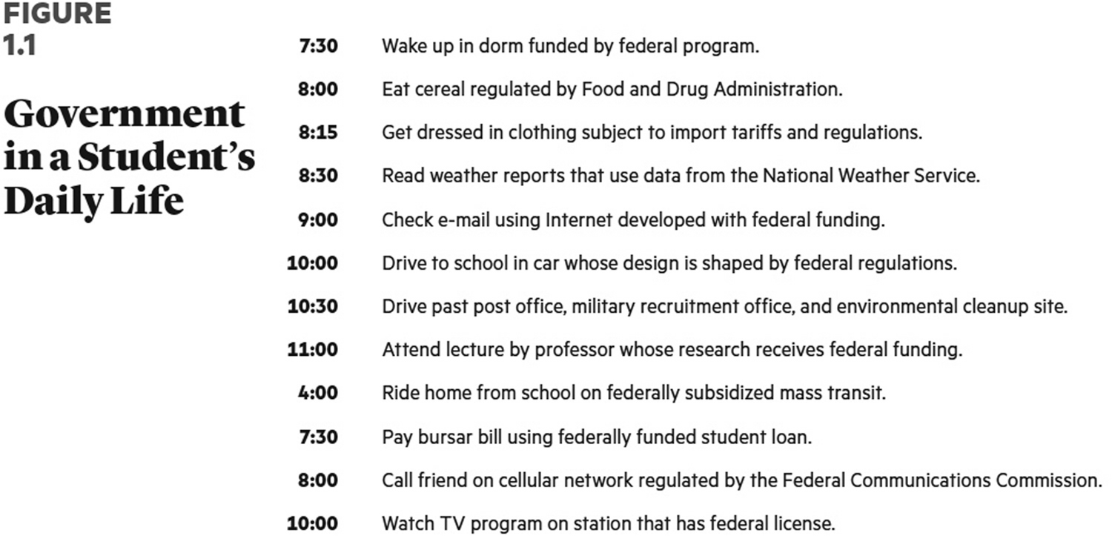
A college student’s life
a. | is typically not affected by federal regulators.
b. | is typically only affected by regulators at the local level.
c. | is affected profoundly by regulators at the federal level.
d. | is only regulated if she or he attends a public university or college.

ANS: C DIF: Moderate REF: CH01 – What Is Politics?
OBJ: Define politics and identify three key ideas that help explain politics
MSC: Applying

19. ________ are likely to disappear quickly from the political agenda, while ________ often
take a long time to resolve.
a. | Conflictual issues; valence issues
b. | Social issues such as abortion; national issues
c. | Consensus issues; conflictual issues
d. | Campaign issues; state and local issues

ANS: C DIF: Moderate REF: CH01 – What Is Politics?
OBJ: Define politics and identify three key ideas that help explain politics
MSC: Remembering

20. Conflict
a. | has only recently been understood in political science.
b. | between interest groups explains most outcomes in American politics.
c. | is rarely studied in the context of Congress, the presidency, and the Supreme Court.
d. | is a natural part of the political process.

ANS: D DIF: Easy REF: CH01 – What Is Politics?
OBJ: Define politics and identify three key ideas that help explain politics
MSC: Understanding

21. Most Americans
a. | enjoy the conflict inherent in politics.
b. | regularly talk about politics with their family members and friends.
c. | avoid discussing politics in order to maintain social harmony.
d. | regularly talk about money and religion with their family members and friends.

ANS: C DIF: Moderate REF: CH01 – What Is Politics?
OBJ: Define politics and identify three key ideas that help explain politics
MSC: Understanding

22. A stealth democracy entails
a. | an attempt to run government like a business.
b. | the willingness to have an extensive debate involving many political players before creating a new public policy.
c. | ignoring fundamental disagreements in politics.
d. | giving more political power to the people.

ANS: A DIF: Difficult REF: CH01 – What Is Politics?
OBJ: Define politics and identify three key ideas that help explain politics
MSC: Understanding

23. What happened as a result of the 2016 elections?
a. | The Republicans lost control of both houses of Congress.
b. | At least one prominent conservative was appointed to the Supreme Court in 2017.
c. | The United States remained in the Paris Agreement.
d. | Not much changed in the transition from the Obama administration to the Trump administration.

ANS: B DIF: Moderate REF: CH01 – What Is Politics?
OBJ: Define politics and identify three key ideas that help explain politics
MSC: Remembering

24. The federal government
a. | has more than 20 million employees.
b. | affects the everyday lives of Americans in many different ways.
c. | has a budget in excess of $10 trillion per year.
d. | is expected to go bankrupt in the next few years.

ANS: B DIF: Moderate REF: CH01 – What Is Politics?
OBJ: Define politics and identify three key ideas that help explain politics
MSC: Understanding

25. The federal government consists of
a. | elected officials, party chairs, and lobbyists.
b. | the president, members of Congress, the justices of the U.S. Supreme Court, and all citizens who vote in elections.
c. | not only the executive bureaucracy but the mass media and interest groups as well.
d. | more than 2 million employees, not including contract and Postal Service workers.

ANS: D DIF: Moderate REF: CH01 – What Is Politics?
OBJ: Define politics and identify three key ideas that help explain politics
MSC: Remembering

26. Which one of the following is part of the modern economic values of the United States?
a. | workplace democracy
b. | economic individualism
c. | economic equality
d. | the greatest good for the greatest number

ANS: B DIF: Moderate REF: CH01 – Sources of Conflict in American Politics
OBJ: Identify major sources of conflict in American politics MSC: Remembering

27. Over time, the United States has experienced
a. | an increase in stratification by class.
b. | a departure from free market principles in its overall economic philosophy.
c. | a sharp increase in political corruption.
d. | economic decline relative to Europe.

ANS: A DIF: Moderate REF: CH01 – Sources of Conflict in American Politics
OBJ: Identify major sources of conflict in American politics MSC: Understanding

28. Democrats and Republicans most strongly disagree about which area of economic policy?
a. | free trade | c. | redistributive tax policy
b. | gold or silver standards for currency | d. | capitalism

ANS: C DIF: Moderate REF: CH01 – Sources of Conflict in American Politics
OBJ: Identify major sources of conflict in American politics MSC: Understanding

29. Which one of the following demonstrates a general understanding of American politics?
a. | It is important to avoid conflict as much as possible.
b. | Politicians should learn to stop partisan bickering.
c. | Fundamental differences on public policy issues will continue.
d. | For the most part, election outcomes in the United States have few consequences.

ANS: C DIF: Difficult REF: CH01 – Sources of Conflict in American Politics
OBJ: Identify major sources of conflict in American politics MSC: Analyzing

30. Cultural and moral values garner attention because
a. | of the tendency of most journalists to distort the news.
b. | they typically achieve bipartisan consensus.
c. | interest groups and activists attempt to keep cultural and moral issues at the top of  the policy agenda.
d. | cultural and moral issues are relatively new, only becoming important in the  twenty-first century.

ANS: C DIF: Moderate REF: CH01 – Sources of Conflict in American Politics
OBJ: Identify major sources of conflict in American politics MSC: Understanding

31. Which one of the following is an important issue to values voters?
a. | the growing gap between the rich and the poor
b. | pornography
c. | improving health care for seniors by strengthening Medicare
d. | protecting collective bargaining rights for teachers, police, and firefighters

ANS: B DIF: Moderate REF: CH01 – Sources of Conflict in American Politics
OBJ: Identify major sources of conflict in American politics MSC: Applying

32. Which one of the following is true about identity politics in the United States?
a. | About 90 percent of African Americans support the Republican Party.
b. | Whites tend to support the Democratic Party.
c. | Latino Americans tend to support the Republican Party.
d. | Asian Americans tend to support the Democratic Party.

ANS: D DIF: Moderate REF: CH01 – Sources of Conflict in American Politics
OBJ: Identify major sources of conflict in American politics MSC: Remembering

33. Which one of the following statements about politics is accurate?
a. | Structural rules are generally not that important, especially with regard to presidential elections.
b. | The procedures for developing federal environmental regulations generally are not controversial.
c. | The ability to determine the rules will generally determine the outcome, especially with regard to tax policy.
d. | The citizenship rules outlined in the Constitution have little effect on society, especially with regard to who can serve as president of the United States.

ANS: C DIF: Difficult REF: CH01 – Sources of Conflict in American Politics
OBJ: Identify major sources of conflict in American politics MSC: Understanding

34. A libertarian is likely to favor
a. | higher spending levels to preserve the environment.
b. | higher spending levels for public education.
c. | higher spending levels for national defense.
d. | tax cuts at the federal level.

ANS: D DIF: Moderate REF: CH01 – Sources of Conflict in American Politics
OBJ: Identify major sources of conflict in American politics MSC: Applying

35. A conservative is likely to
a. | vote Democratic.
b. | favor the legalization of marijuana.
c. | favor laws restricting or abolishing abortion.
d. | vote for Independents.

ANS: C DIF: Moderate REF: CH01 – Sources of Conflict in American Politics
OBJ: Identify major sources of conflict in American politics MSC: Applying

36. The women’s movement
a. | was focused on many issues in the nineteenth century.
b. | was dominated by two major issues in the late nineteenth and early twentieth centuries.
c. | is largely focused on getting a female elected president in the contemporary era.
d. | achieved political victories after a short period of time once it started in the mid-nineteenth century.

ANS: B DIF: Moderate REF: CH01 – Sources of Conflict in American Politics
OBJ: Identify major sources of conflict in American politics MSC: Understanding

37. Which one of the following is true about cultural issues in the United States?
a. | Red states tend to be more secular.
b. | Blue states tend to be more religious.
c. | School vouchers remain controversial.
d. | Immigration issues tend not to be controversial.

ANS: C DIF: Moderate REF: CH01 – Sources of Conflict in American Politics
OBJ: Identify major sources of conflict in American politics MSC: Applying

38. How does equality contribute to resolving conflict in the political system?
a. | People respect the system more if they believe they are going to be treated equally.
b. | By promising equal outcomes, politicians have ensured everyone is satisfied.
c. | Conflict can only exist when people are being treated differently.
d. | Multiculturalism reinforces equality of opportunity in America.

ANS: A DIF: Difficult
REF: CH01 – Resolving Conflict: Democracy and American Political Values
OBJ: Explain how the American values of democracy, liberty, and equality work to resolve political conflict MSC: Understanding

39. To the founders of the American republic,
a. | equality was the central principle of government.
b. | commerce was the central principle of government.
c. | liberty was the central principle of government.
d. | all people should own the same amount of property.

ANS: C DIF: Difficult
REF: CH01 – Resolving Conflict: Democracy and American Political Values
OBJ: Explain how the American values of democracy, liberty, and equality work to resolve political conflict MSC: Understanding

40. Fake news
a. | never existed until the 2016 presidential election.
b. | is news that is, while open to interpretation, deliberately made up for profit or to influence politics.
c. | is based on the reality that American politics does not involve much conflict.
d. | exists despite Americans having deep knowledge of politics and public affairs.

ANS: B DIF: Moderate REF: CH01 – How to Be a Critical Consumer of Politics
OBJ: Understand how to interpret, evaluate, and use political information
MSC: Understanding

SHORT ANSWER

1. What two broad purposes are served by government?

ANS:
Governments exist to provide order and to promote general welfare. On one hand, as Thomas Hobbes contended, without government there would be chaos and the state of nature would exist. On the other hand, government exists in order to make the lives of citizens better. There are some problems that individuals cannot address (for example, climate change, terrorist threats, and taking care of the sick). Government action is needed so that societal problems can be addressed.

DIF: Moderate REF: CH01 – Making Sense of American Government and Politics
OBJ: Describe the basic functions of government MSC: Understanding

2. According to the framers of the Constitution, what are two vital functions of government in the United States? Cite evidence from the Constitution itself.

ANS:
Two vital functions are policing and providing national security. Evidence of this vision of the framers exists in the preamble of the Constitution. Two goals established by the framers were to “provide for the common defense” (national security) and “insure domestic tranquility” (police protection). National security is provided by the national government and all levels of government contribute to police protection and law enforcement.

DIF: Moderate REF: CH01 – Making Sense of American Government and Politics
OBJ: Describe the basic functions of government MSC: Understanding

3. What is the difference between separation of powers and federalism?

ANS:
The focus of separation of powers is strictly on the national government. The framers assigned lawmaking authority to Congress, law-enforcement authority to the president, and interpreting the meaning of the laws to the Supreme Court. Federalism is the constitutional division of power between the national government and the states. Local governments are appendages of the states legally, and they are not included in the Constitution, though they obviously existed in 1787. The framers concluded that a stronger national government was needed to stabilize the fledgling democracy that was created by the Articles of Confederation. In so doing, the framers believed that a federal republic would best serve the needs of the people. While more authority was granted to the national government under the Constitution, the power of the states was still recognized and preserved.

DIF: Moderate REF: CH01 – Making Sense of American Government and Politics
OBJ: Describe the basic functions of government MSC: Understanding

4. What is meant by a “stealth democracy”?

ANS:
According to political scientists John Hibbing and Elizabeth Theiss-Morse, a stealth democracy is a governmental structure where nondemocratic practices are routine, such as running government like a business or establishing public policy without a political debate. These experts argue that avoidance of conflict in politics is impossible; such avoidance will not make fundamental disagreements between people disappear. In a democracy, people are free to express their opinions, which oftentimes clash with the opinions of other citizens. This type of conflict is preferred because without it government leaders would be free to establish policy as they wished (as chief executive officers routinely do in the private sector). The presence of conflict is a healthy sign of democracy in action. The challenge, however, is to manage the conflict in question.

DIF: Moderate REF: CH01 – What Is Politics?
OBJ: Define politics and identify three key ideas that help explain politics
MSC: Understanding

5. Most Americans generally view politics in a negative manner. Regardless, provide an issue that illustrates why politics is important to all Americans and explain why this is the case.

ANS:
Responses will vary and be a function of student interest. What’s important is that students make a causal connection between the concept of politics and its importance and apply it to the contemporary world.

DIF: Moderate REF: CH01 – What Is Politics?
OBJ: Define politics and identify three key ideas that help explain politics
MSC: Evaluating

6. What are the dominant beliefs of liberals, conservatives, and libertarians in the United States today?

ANS:
Liberals generally favor the promotion of social equality and support more government intervention in social programs, more market regulation, and government policies that promote tolerance. Conservatives generally espouse individual freedom, typically favor less government intervention in social programs and the domestic economy, and typically favor traditional social practices. Libertarians prefer very limited government. They believe government should exist to keep citizens safe along with a few narrowly defined responsibilities. Thus, libertarians are generally conservative on social, economic, and regulatory matters but generally liberal on issues involving personal liberty and privacy.

DIF: Moderate REF: CH01 – Sources of Conflict in American Politics
OBJ: Identify major sources of conflict in American politics MSC: Understanding

7. Why was liberty the central principle of the framers of the Constitution?

ANS:
Liberty was the central principle due to the context of the times. The framers believed that people should be free to express their political views. In so doing, the framers understood that conflict would be the norm in American politics. To James Madison, in particular, there was natural tension between liberty and conflict. He believed that suppressing conflict by limiting freedom was unacceptable in a republican form of government.

DIF: Moderate REF: CH01 – Resolving Conflict: Democracy and American Political Values
OBJ: Explain how the American values of democracy, liberty, and equality work to resolve political conflict MSC: Understanding

8. Is democracy the only way to resolve conflict in a society?

ANS:
Democracy is not the only way to resolve conflict in a given society. Not all citizens in the world have a fundamental belief in democracy as most Americans do. Though citizens in a democracy may struggle to address conflictual issues, leaders in authoritarian regimes seek to suppress conflict through violence and by limiting freedom. To those who have a democratic ethos, a transparent debate about controversial matters is preferable to having no debate at all because those in power have limited freedom of speech and expression.

DIF: Moderate REF: CH01 – Resolving Conflict: Democracy and American Political Values
OBJ: Explain how the American values of democracy, liberty, and equality work to resolve political conflict MSC: Understanding

9. Why do Americans need to be critical consumers of politics?

ANS:
A significant challenge for Americans in the information age is to decide which news sources to believe and which ones to disregard. With a plethora of news outlets available, it is recommended that Americans gather information from multiple sources, especially if any of the sources in question have a discernible ideological bias. Americans should also question sources that present a simple explanation for a complex phenomenon. Politics is complicated by definition.

DIF: Moderate REF: CH01 – How to Be a Critical Consumer of Politics
OBJ: Understand how to interpret, evaluate, and use political information
MSC: Understanding

ESSAY

1. According to Thomas Hobbes, why do we have government? Does his conclusion from the seventeenth century still apply in the twenty-first century? Explain.

ANS:
According to Hobbes, governments are created in order to avoid chaos and the state of nature. Without rules, people could do whatever they wanted and the state of nature would be a very cruel and violent place. In particular, no system for policing and national security would be in place. Thus, his theory is still applicable. Governments are still needed; it is important to keep reforming government so that its relative effectiveness is enhanced over time.

DIF: Moderate REF: CH01 – Making Sense of American Government and Politics
OBJ: Describe the basic functions of government MSC: Analyzing

2. James Madison wrote, “If men were angels, no government would be necessary. If angels were to govern men, neither external nor internal controls on government would be necessary.” Explain what this quote means. Do you believe it to be true? What kind of institutional controls did Madison put into the Constitution as a consequence of his beliefs, and are they effective?

ANS:
Reponses will vary to some extent depending upon the context of the individual student. However, Madison perceived that most Americans were basically self-interested and was concerned that they would not put the interests of the nation as a whole ahead of their own individual or family self-interest. Thus, governments are necessary in order for leaders to create policies that promote the greater common good. Yet leaders in government are human just like common citizens, so he believed that they had to be held accountable for their actions as well. That is why the framers collectively embraced both the notion of separation of powers and checks and balances. Students can define both terms and provide concrete illustrations directly from the Constitution.

DIF: Difficult REF: CH01 – Making Sense of American Government and Politics
OBJ: Describe the basic functions of government MSC: Evaluating

3. 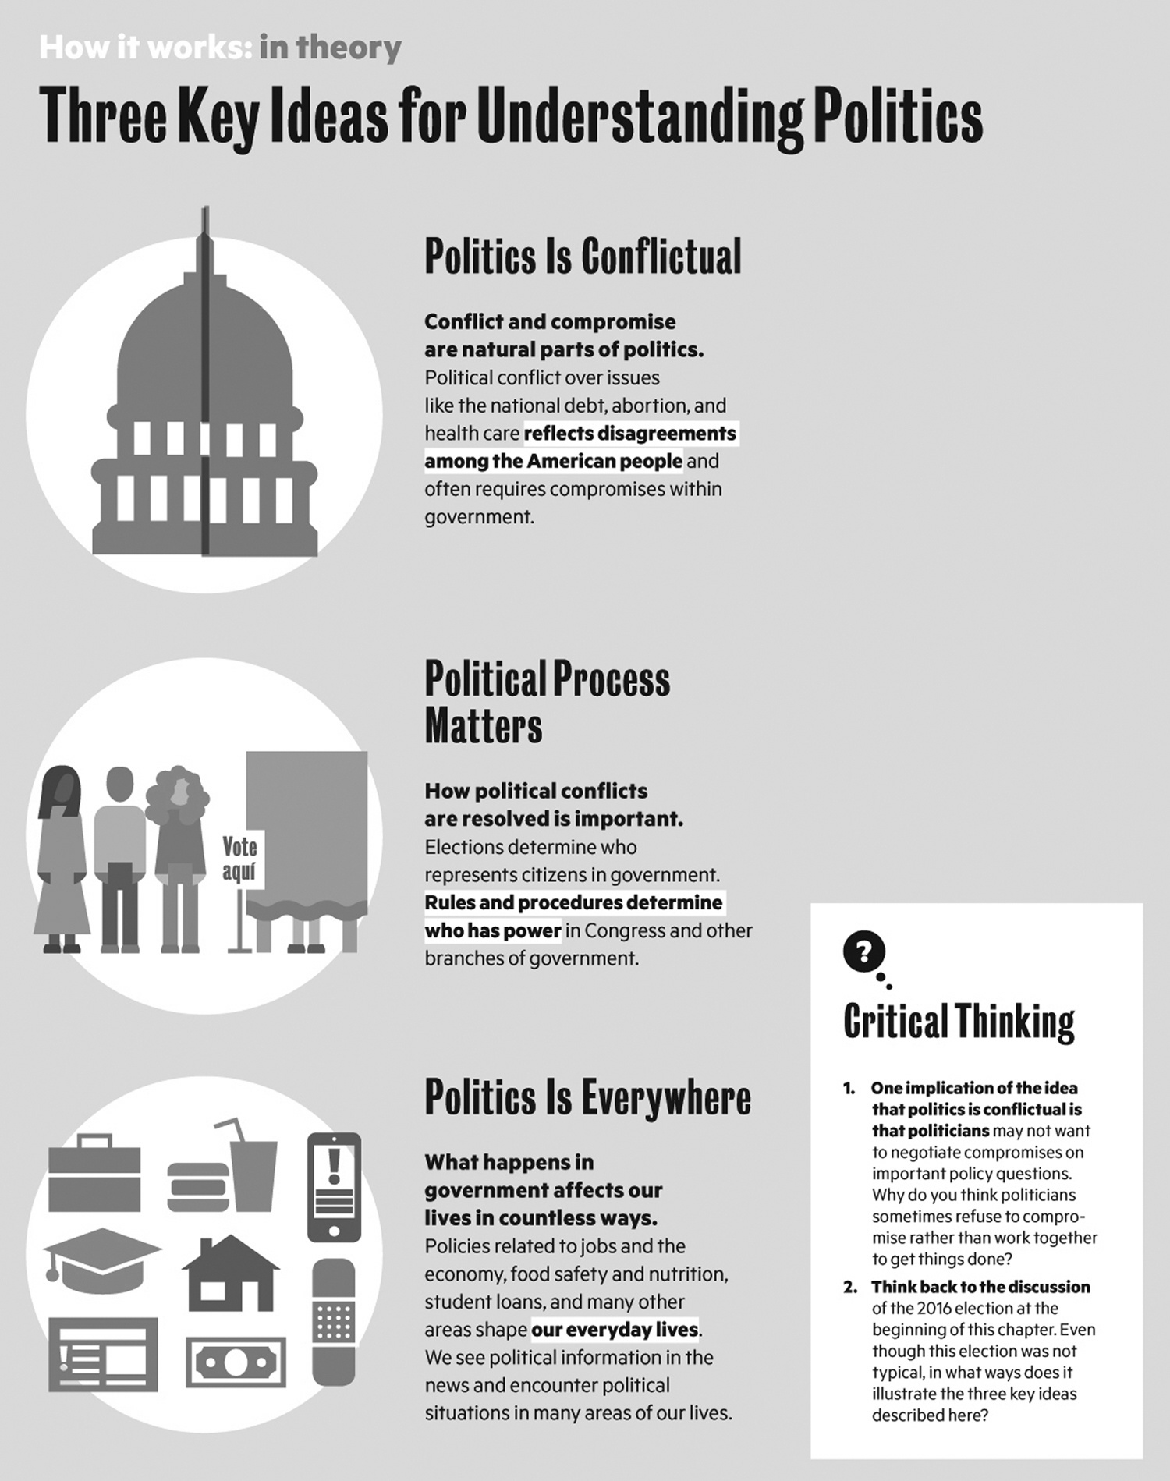
Select one of the following policy issues and discuss how the three key ideas are central to understanding this policy debate: health care, campaign finance reform, national debt, or abortion.

ANS:
The three key ideas are as follows: politics is conflictual, and conflict and compromise are natural components of politics; political process matters because how political conflicts are resolved is important; and politics is everywhere because what happens in government affects citizens’ lives in countless ways. Responses will vary to the latter question about selecting a specific policy debate depending, in part, on the values and beliefs of the individual student.

DIF: Moderate REF: CH01 – What Is Politics?
OBJ: Define politics and identify three key ideas that help explain politics
MSC: Applying

4. Compare and contrast liberals, conservatives, and libertarians on their views regarding the domestic economy. Provide a concrete example to illustrate ideological differences between the groups.

ANS:
Liberals tend to prioritize the promotion of social equality as their most important objective. As a result, they tend to favor more government intervention in the economy, especially to assist the poor and groups that have endured historical and continuing discrimination. Conservatives tend to prioritize individual freedom as their paramount goal. As such, they tend to favor less regulation and lower taxes, and they embrace a free market approach to economics. Libertarians favor less regulation than conservatives. To them, government should only provide for the national defense and protect people from fraud. Otherwise, government officials should let people do what they want. One example is the federal minimum wage law. Liberals believe that it should be increased to make it more of a living wage to help the poor. Conservatives tend to oppose increasing the minimum wage because it is too intrusive on the marketplace and will result in unintended job losses. Libertarians, as well as some conservatives, believe that the minimum wage should be abolished and wages should be negotiated between the employer and employee.

DIF: Difficult REF: CH01 – Sources of Conflict in American Politics
OBJ: Identify major sources of conflict in American politics MSC: Analyzing

5. Identify and define the core American political values and explain how they are central to thinking about and understanding American politics.

ANS:
Three core political values in America include liberty, democracy, and equality. Liberty was the central principle for the framers of the Constitution. Fundamentally, the framers believed that citizens must have the freedom to express their political views, even if those beliefs were unpopular. Liberty entails political freedom, such as freedom of speech, press, assembly, and religion under the First Amendment. Democracy means government by the people. In the context of the United States, the framers created a republican form of government, or a representative democracy. Citizens elect leaders to govern on their behalf. Another core value is equality, which means equal protection of the laws in the United States. Political equality is where each person gets exactly one vote, and equality of opportunity means that all people have the chance to realize their potential. Equality does not mean that all people have material equality. These values are central to understanding American politics because Americans have collectively accepted these core beliefs. As such, the extreme politics that were commonly witnessed in Europe did not evolve in the same manner in this country.

DIF: Moderate REF: CH01 – Resolving Conflict: Democracy and American Political Values
OBJ: Explain how the American values of democracy, liberty, and equality work to resolve political conflict MSC: Understanding

