Chapter 1 TestBank for Complete A+ Guide to IT Hardware and Software ISBN 9780789756459

Copyright © 2020 by Pearson Education, Inc.
All rights reserved.
Chapter 1 Introduction to the World of IT
1.1 True/False Questions

1) When a technician asks the computer operator whether the computer boots, the technician is asking an open-ended question.
Answer: FALSE
Diff: 3

2) The power supply is the part of the computer that converts the wall outlet AC voltage to DC voltage.
Answer: TRUE
Diff: 1

3) The Caps Lock is a common keyboard light.
Answer: TRUE
Diff: 1

4) RAM is volatile.
Answer: TRUE
Diff: 3

5) RAM is not volatile.
Answer: FALSE
Diff: 3

6) It is best when you are picking up a heavy laser printer to bend at your knees and use your legs to lift.
Answer: TRUE
Diff: 1

7) Windows 10, Android, and Microsoft Office are all operating systems.
Answer: FALSE
Diff: 2

8) A megabyte is larger than a terabyte.
Answer: FALSE
Diff: 2

9) If you want a particular word included in a web search, place a minus sign (-) in front of the word.
Answer: FALSE
Diff: 2

10) The BIOS is an example of hardware.
Answer: FALSE
Diff: 3

11) Working inside a power supply can cause harm to an improperly trained technician.
Answer: TRUE
Diff: 2

12) Text files can be used to document technical problems.
Answer: TRUE
Diff: 1

13) An adapter fits in an expansion slot.
Answer: TRUE
Diff: 1

14) An example of a positive attitude is when you do not take time to listen to the entire customer problem.
Answer: FALSE
Diff: 1

15) The optical drive can be an internal computer component.
Answer: TRUE
Diff: 1

16) A display is a common input device.
Answer: FALSE
Diff: 2

17) A touchscreen is an input device.
Answer: TRUE
Diff: 2

18) One recommended way of cleaning a keyboard is to spray a cleaning solution such as glass cleaner on it and dry with a damp cloth.
Answer: FALSE
Diff: 2

19) Job requirements for PC technicians frequently have a weight lifting requirement of 100 pounds.
Answer: FALSE
Diff: 2

20) A mouse typically uses optical sensors to move the cursor on the screen.
Answer: TRUE
Diff: 2

1.2 Multiple Choice Questions

1) Experience, knowledge of the basic hardware components, and a logical mind are characteristics associated with a
A) System resource specialist
B) Free thinker
C) Computer technician
D) Personal digital assistant
Answer: C
Diff: 1

2) A curious computer user is ready to check out a CRT video problem with a computer system. Because of safety concerns, which one of the following procedures should be carried out only after receiving specialized technical training?
A) Turning the monitor power off and pushing the power cord plug firmly into its socket on the back of the monitor
B) Unplugging the monitor, removing its case, and probing various components
C) Unplugging the PCʹs power cord from the wall
D) Turning the computer off before removing the computer cover
Answer: B
Diff: 2

3) Microsoft Server, Windows 8, Solitaire, Acrobat Reader, Flash Player, Microsoft Word, WordPerfect, and Lotus 1-2-3 are all examples of
A) Software
B) Operating systems
C) Firmware
D) Hardware
Answer: A
Diff: 2

4) A computer power supply
A) Converts the DC voltage that comes out of the wall to AC voltage the computer can use
B) Supplies DC voltage to the internal parts of the computer
C) Allows input of data and is used to select menus and options
D) Is a rectangular box normally inside the computer case that is sealed to keep out dust and dirt
Answer: B
Diff: 1

5) From the following groups of terms, select one group whose items are incorrectly matched:
A) Motherboard: mainboard, planar, systemboard
B) Memory: RAM, card, DVD
C) Adapter: controller, controller card, circuit card
D) Computer: tower, desktop, mobile
Answer: B
Diff: 3
6) The largest electronic board in the computer is the _____.
A) Masterboard
B) Superboard
C) Motherboard
D) Controller board
Answer: C
Diff: 1

7) Which device is an input only device?
A) Motherboard
B) Keyboard
C) Printer
D) MIDI device
Answer: B
Diff: 3

8) Which capacity is approximately one million bytes?
A) Kilobyte
B) Megabyte
C) Terabyte
D) Gigabyte
Answer: B
Diff: 2

9) In which type of memory is data lost when the electricity to the computer is turned off?
A) RAM
B) ROM
C) BIOS
D) Flash BIOS
Answer: A
Diff: 1

10) RAM stands for
A) Random Activity Modules
B) Real-time Active Memory
C) Reset Asset Maintenance
D) Random Access Memory
Answer: D
Diff: 1

11) A byte is made up of ____ bits.
A) 1
B) 2
C) 4
D) 8
Answer: D
Diff: 1
12) A kilobyte is equivalent to
A) Approximately 500 megabytes
B) Approximately 1,000 bytes
C) Approximately 1 gigabyte
D) Approximately 32 bits
Answer: B
Diff: 2

13) 1M, 1,000,000 bytes, and 1,024 kilobytes are all terms associated with a
A) Melabyte
B) Megabyte
C) Milobyte
D) Minkobyte
Answer: B
Diff: 2

14) From the following choices, select the one arranged in order from lowest to highest:
A) Bit, byte, kilobyte, megabyte, gigabyte, terabyte
B) Terabyte, gigabyte, megabyte, kilobyte, byte, bit
C) Exabyte, terabyte, kilobyte, megabyte, gigabyte
D) Sadobyte, masobyte, pedobyte, arachnobyte
Answer: A
Diff: 3

15) 2 to the 20th power, or 1,048,576, is equal to a
A) Megabyte
B) Gibibyte
C) Kibibyte
D) Metabyte
Answer: A
Diff: 3

16) A desktop CRT monitor
A) Has DC power input
B) Requires an available USB port
C) Should not be disassembled
D) Holds the BIOS chip that holds POST
Answer: C
Diff: 2

17) After pushing the power switch of the PC to the ʺonʺ position, Bob, the PC repair person, realizes that the power-on lights found on the monitor and computer case do not light up and nothing displays on the screen. The first thing that Bob does is check the power plugs found on the back of the computer case and monitor. Bobʹs actions best illustrate the use of _____ in solving a problem.
A) Logic
B) Communication
C) Professional and technical training
D) Beginnerʹs luck
Answer: A
Diff: 3

18) Red Hat, iOS, Windows 10, and OS X are all examples of
A) Shareware
B) Firmware
C) Hardware
D) Operating systems
Answer: D
Diff: 1

19) From the following groups of terms, select one group whose items are incorrectly matched:
A) Storage: floppy disk drives, hard disk drives, optical drives
B) Software: Windows Vista, applications, operating system
C) Hardware: PC, power supply, motherboard
D) Firmware: BIOS, software, mouse
Answer: D
Diff: 3

20) The ____ holds most of the electronics, expansion slots, and memory.
A) Motherboard
B) Processor
C) Hard drive
D) Power supply
Answer: A
Diff: 1

21) The common components found inside the computer include:
A) Motherboard, power supply, RAM, expansion slots
B) Printer, scanner plotter, keyboard, graphics tablet, motherboard
C) Motherboard, backup drive, video camera, trackball
D) Monitor, keyboard, mouse, power supply, floppy drive, hard drive, adapters
Answer: A
Diff: 2

22) From the following groups of terms, select one group whose items are correctly matched:
A) Adapter cards: controller card, circuit card, adapter board
B) Motherboard: mainboard, system board, expansion board
C) Memory: RAM, DIMM, S/PDIF
D) Operating system: XP, Celluloid, iOS
Answer: A
Diff: 3

23) Joy is concerned that the computer she owns cannot simultaneously run as many programs as the computer that belongs to her neighbor. To keep up with her neighbor, she might need to buy some additional
A) ROM
B) BIOS
C) Firmware
D) RAM
Answer: D
Diff: 3

24) Examine the figure below. Item 1 is called a(n)
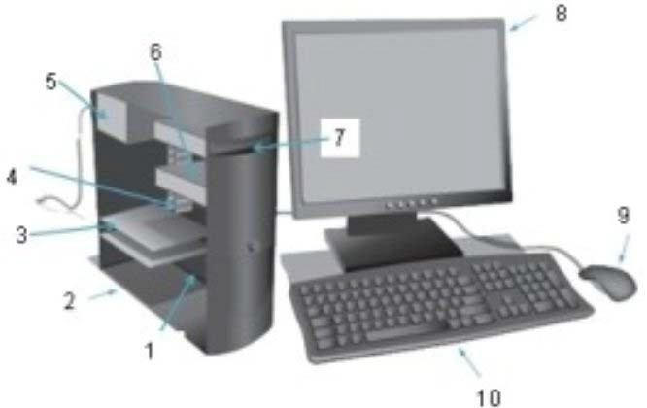

A) Hard disk
B) Optical drive
C) Power supply
D) Motherboard
Answer: D
Diff: 2
25) Examine the figure below. Item 2 is called a(an)

A) Case
B) Optical drive
C) Power supply
D) Motherboard
Answer: A
Diff: 2

26) Examine the figure below. Item 3 is called a(n)

A) Case
B) Adapter
C) Riser
D) Motherboard
E) Hard drive
Answer: B
Diff: 2

27) Examine the figure below. Item 4 is called a(n)

A) Riser
B) Adapter
C) Hard drive
D) Motherboard
E) Memory module
Answer: E
Diff: 2

28) Examine the figure below. Item 5 is called a(n)

A) Case
B) Riser
C) Hard drive
D) Optical drive
E) Power supply
Answer: E
Diff: 2

29) Examine the figure below. Item 6 is called a(an)

A) Case
B) Riser
C) Hard drive
D) Power supply
E) Optical drive
Answer: C
Diff: 2

30) Examine the figure below. Item 7 is called a(n)

A) Case
B) Riser
C) Power supply
D) Optical drive
Answer: D
Diff: 2

31) Examine the figure below. Item 8 is called a(n)

A) Case
B) Riser
C) Display
D) Power supply
E) Motherboard
Answer: C
Diff: 1

32) Examine the figure below. Item 9 is called a(n)

A) Case
B) Mouse
C) Monitor
D) Power supply
E) Optical drive
Answer: B
Diff: 1

33) Examine the figure below. Item 10 is called a(n)

A) Riser
B) Mouse
C) Display
D) Keyboard
Answer: D
Diff: 1

34) Examine the figure below. The part shown as 1 is the
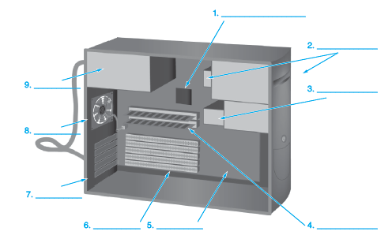

A) CPU
B) RAM
C) Expansion slot
D) Motherboard
Answer: A
Diff: 3

35) Examine the figure below. The part shown as 5 is the

A) CPU
B) RAM
C) Expansion slot
D) Motherboard
Answer: D
Diff: 2

36) Examine the figure below. The part shown as 6 is the

A) CPU
B) RAM
C) Expansion slot
D) Motherboard
Answer: C
Diff: 2

37) Examine the figure below. The part shown as 2 is the

A) CPU
B) Optical drive
C) Expansion slot
D) Motherboard
Answer: B
Diff: 2

38) What is the best method to use when cleaning the optical sensors on a wireless mouse?
A) Compressed air
B) Mild detergent
C) Alcohol
D) Monitor wipes
Answer: A
Diff: 2

39) What is one of the easiest ways to determine whether a keyboard is working?
A) Press Caps Lock to see whether the associated light illuminates.
B) Run POST.
C) Check in the System BIOS.
D) Run keyboard diagnostics from within the Start button Accessories option.
Answer: A
Diff: 2

40) Why is having the correct device driver so important?
A) It enables a specific operating system to run as multiple machines.
B) It enables multiple computers to share devices.
C) It enables a device to work in both a powered and unpowered state.
D) It enables a specific operating system to control a specific piece of hardware.
Answer: D
Diff: 2

41) What is the primary purpose of the power supply?
A) Controls internal computer temperature
B) Converts AC to DC
C) Provides power to external devices
D) Supplies AC electricity to the computer parts
Answer: B
Diff: 1

42) Where is the motherboard on a tower computer?
A) On the bottom
B) On the side
C) On the top
D) In the middle
Answer: B
Diff: 1

43) What statement is true regarding RAM and ROM?
A) ROM commonly holds the computer operating system.
B) ROM commonly holds stored user data such as photographs.
C) RAM commonly stores data such as user photos that are retrieved on a later date.
D) RAM contents are lost when the computer is powered off.
Answer: D
Diff: 2

44) What type of memory would a PC most likely use to hold an application you are currently using?
A) RAM
B) ROM
C) Flash
D) Optical
Answer: A
Diff: 2

45) Which of the following questions would be open-ended and allow a technician to discover the problem?
A) Did the problem occur today for the first time?
B) What time did the problem occur first?
C) Could you show me the problem?
D) How often does the problem occur?
Answer: C
Diff: 2

46) Which of the following search parameters would allow Internet searches and require the search engine to only provide sites related to the search for Windows 8 shutdown issues and not Windows 7 or Windows 10 issues?
A) “Windows 8” AND shutdown
B) Windows shutdown issues
C) Windows 8 shutdown issues
D) Windows 8 | shutdown issues
Answer: A
Diff: 3

47) What quality is a technician exhibiting if the technician constantly says “I can’t do that” when asked to help others on the team?
A) Business smarts
B) Negative attitude
C) Self preservation
D) Aggressiveness
Answer: B
Diff: 2

48) What certification might be required of IT personnel on a help desk?
A) CCPC
B) CCIE
C) DNA
D) A+
Answer: D
Diff: 2

49) What certification might be required of a computer repair person?
A) PCMA
B) A+
C) CCIA
D) Hyper-V
Answer: B
Diff: 2

50) Which of the following is not a search engine?
A) Bing
B) Google
C) Yahoo
D) Search
Answer: D
Diff: 2

51) Which of the following would be best to use in a search engine when searching for a Windows 10 boot problem?
A) “Windows 10” AND boot AND problem
B) Windows 10 boot problem
C) Microsoft Windows problem
D) Microsoft 10 problem boot* AND issu*
Answer: A
Diff: 2

52) What do you do as a technician if an Internet search has no relevant links on the first page?
A) Try the same search in a different search engine.
B) Reboot the computer.
C) Try different search terms.
D) Add quotation marks before the first term and after the last term.
Answer: C
Diff: 1

53) A technician is describing a computer problem to a peer technician, but the workmate doesn’t seem to understand. What Windows tool could the technician use to take a picture of the problem to email to the other technician?
A) Notepad
B) Wordpad
C) PicIT
D) Snipping Tool
Answer: D
Diff: 2

54) What Windows tool is used to document a computer problem in a .txt file that could be attached to a problem ticket?
A) Notepad
B) Word
C) DocIT
D) Snipping Tool
Answer: A
Diff: 2

55) Refer to the figure below. What component is shown?
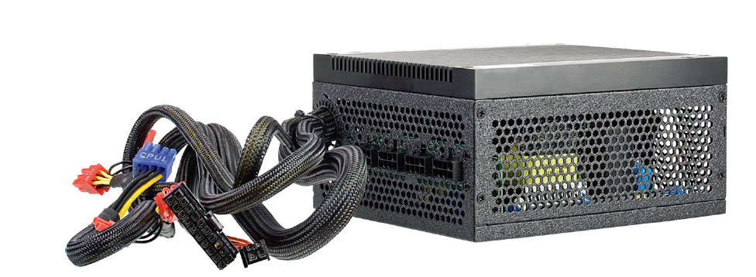

A) Motherboard
B) Case fan
C) Power supply
D) Memory
Answer: C
Diff: 1

56) Refer to the figure below. What component is shown?

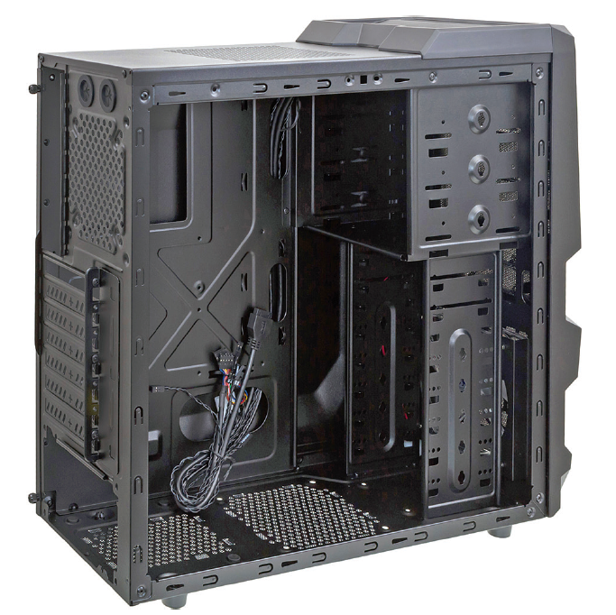

A) Motherboard
B) Power supply
C) Memory
D) Case
Answer: D
Diff: 1

57) Refer to the figure below. What component is labelled as 1?
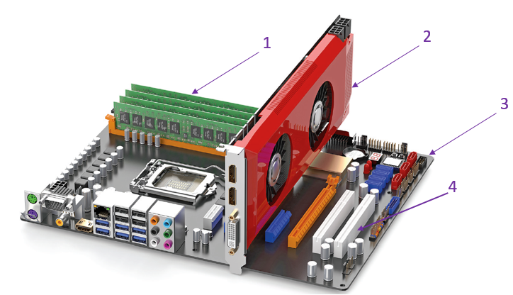

A) Motherboard
B) Power supply
C) Memory
D) Case
Answer: C
Diff: 1

58) Refer to the figure below. What component is labelled as 2?

A) Motherboard
B) Adapter
C) Memory
D) Case
Answer: B
Diff: 1

59) Refer to the figure below. What component is labelled as 3?

A) Motherboard
B) Power supply
C) Memory
D) Adapter
Answer: A
Diff: 1

60) Refer to the figure below. What component is labelled as 4?

A) Motherboard
B) Expansion slot
C) Memory
D) Power connector
Answer: B
Diff: 2

61) Refer to the figure below. What component is shown?
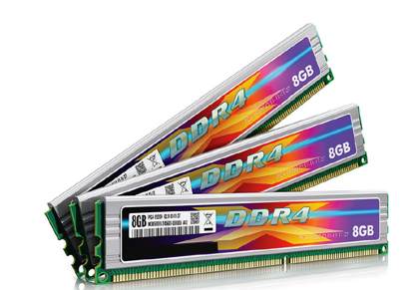

A) Motherboard
B) Power supply
C) Memory
D) Adapter
Answer: C
Diff: 1

62) Refer to the figure below. What component is shown?

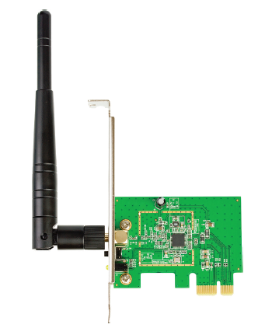

A) MotherboardC
B) Power supply
C) Memory
D) Adapter
Answer: D
Diff: 1
A) Motherboard
B) Optical Drive
C) Memory
D) Adapter
Answer: D
Diff: 1

63) Refer to the figure below. What component is shown?

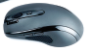

A) Keyboard
B) Mouse
C) Memory
D) Adapter
Answer: B
Diff: 1

64) Refer to the figure below. What component is shown?
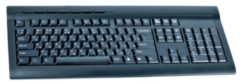

A) Keyboard
B) Mouse
C) Memory
D) Adapter
Answer: A
Diff: 1

65) What is one way to clean a keyboard?
A) Spray it with a cleaning solution like window cleaner.
B) Disconnect it and shake out debris.
C) Use cotton swabs and a bit of bleach to get between keys.
D) Take a hair brush between the keys.
Answer: B
Diff: 2

66) What is one way to clean a keyboard?
A) Use compressed air.
B) Spray it with a cleaning solution like window cleaner.
C) Use cotton swabs and a bit of bleach to get between keys.
D) Take a hair brush between the keys.
Answer: A
Diff: 1

67) Jimmy, a computer technician, is told that one particular key doesn’t work on a keyboard. What should Jimmy do first?
A) Remove the key and use compressed air.
B) Spray the problem area with a cleaning solution like window cleaner.
C) Use cotton swabs and a bit of bleach to get under the key.
D) Replace the keyboard.
Answer: A
Diff: 2

68) How can you tell the difference between a bit and a byte when a particular capacity is shown like 6 GB?
A) You have to see the word in context.
B) When the capacity has no B after it, then bits are to be assumed.
C) A lowercase b denotes bits; uppercase means bytes.
D) Where PCs are concerned, bytes are always used.
Answer: C
Diff: 2

69) What is one piece of advice other technicians should share with Sofia, the newest member of the team, that she might not think about?
A) Do not wear skirts to work.
B) Wear a hat to fit in with the team.
C) Be careful when walking and carrying components.
D) Remove jewelry before working inside a computer.
Answer: D
Diff: 2

70) What is a piece of advice for new technicians entering the PC repair field?
A) Wear a hat when working inside a computer.
B) Bend at the knees when lifting a heavy component.
C) Be careful when walking and carrying components.
D) Carry a flashlight with you at all times.
Answer: B
Diff: 2

71) What component allows multiple computers to share a keyboard?
A) UPS
B) KVM
C) Docking station
D) Projector
Answer: B
Diff: 2

72) Which peripheral reads a series of vertical lines?
A) UPS
B) Barcode Scanner
C) Docking station
D) Projector
Answer: B
Diff: 2

73) A device that can read data from a card that has a magnetic strip would be called.?
A) Flatbed Scanner
B) Barcode Scanner
C) NFC Device
D) Smart Card Reader
Answer: D
Diff: 2

74) What is another name for a DVD storage device?
A) Flatbed Scanner
B) Floppy Drive
C) Hard Drive
D) Optical Drive
Answer: D
Diff: 2

1.3 Multiple Answer Questions
1) Which two parts are commonly input devices? (Select two.)
A) Mouse
B) Hard drive
C) Display
D) Motherboard
E) Keyboard
Answer: A, E
Diff: 2

2) Which methods are used when cleaning a keyboard? (Select all that apply.)
A) Turn the keyboard upside down over a trash can and gently shake out debris.
B) Use compressed air.
C) Use cleaning wipes.
D) Vacuuming.
E) Brushing.
F) Remove all keys and vacuum.
Answer: A, B, C, D, E
Diff: 2

3) What are three of the best qualities for a computer technician? (Select all that apply.)
A) Is a good listener
B) Has a good, professional attitude
C) Uses appropriate vocabulary when speaking of technology
D) Can fix every computer problem
E) Is never late for work
F) Uses resources efficiently
Answer: A, B, C
Diff: 2

4) Which items are operating systems? (Select all that apply.)
A) Ubuntu
B) Intel
C) OS X
D) Windows 10
E) AMD
F) Stellar
G) Fox
Answer: A, C, D
Diff: 1

5) What are three purposes of a power supply? (Select three.)
A) Converts AC to DC
B) Converts DC to AC
C) Computer cooling
D) Impedance matching
E) CPU liquid cooling
F) Distribute DC to the computer parts
Answer: A, C, F
Diff: 2

6) Which of the following questions are closed-ended and allow a technician to discover the problem? (Choose all that apply.)
A) Did the problem occur today for the first time?
B) What time did the problem occur first?
C) Could you show me the problem?
D) How often does the problem occur?
Answer: A, B, D
Diff: 2

7) Which two of the following search engine queries are equivalent? (Select two.)
A) monitor problem or display problem
B) “monitor problem” or “display problem”
C) monitor or display problem
D) monitor display problem
E) “monitor problem” | “display problem”
Answer: B, E
Diff: 2

1.4 Matching Questions

1) Match the term with the description.
Terabyte
Kilobyte
Mebibyte
Byte
Bit
Kibibyte
A. 8 bits
B. 1,024
C. 1 or 0
D. Approximately 1 thousand bytes
E. Approximately 1 trillion bytes
F. 1,048,576
Answer: E, D, F, A, C, B
Diff: 3

2) Match the part to the description.
Hard drive
Power supply
Mouse
Adapter
RAM
Motherboard
Display
BIOS
A. Memory
B. Output screen
C. Holds processor and memory
D. Contains firmware
E. Outputs DC
F. Tower computer expansion
G. Large storage device
H. Input device
Answer: G, E, H, F, A, C, B, D
Diff: 2

1.5 Fill-in-the-Blank Questions

1) In computer technology, a 1 or a 0 is a(n) __________.
Answer: bit
Diff: 1

2) An operating system is an example of __________.
Answer: software
Diff: 1

3) The hard drive, keyboard, and monitor are examples of __________.
Answer: hardware
Diff: 1

4) An example of a small input device that uses optics to move the display cursor is a(n) __________.
Answer: mouse
Diff: 1

5) The __________ ___________ provides DC voltage to various parts of a computer.
Answer: power supply
Diff: 1

6) Adapters plug into a(n) __________ ___________ on the motherboard.
Answer: expansion slot
Diff: 2

7) A combination of eight 1s and 0s is a(n) __________.
Answer: byte
Diff: 1

8) The most common type of memory found on the motherboard that can be expanded is __________. Note: Use the acronym (the letters) commonly used for this part.
Answer: RAM
Diff: 2

9) The chip that contains software to start the computer is the ___________. Note: Use the acronym (the letters) commonly used for this part.
Answer: BIOS
Diff: 2

10) Approximately 1,000 (one thousand) bytes is a(n) __________.
Answer: kilobyte, kB
Diff: 2

11) Approximately 1,000,000 (one million) bytes is a(n) __________.
Answer: megabyte, MB
Diff: 2

12) Approximately 1,000,000,000 (one billion) bytes is a(n) __________.
Answer: gigabyte, GB
Diff: 2

13) Approximately 1,000,000,000,000 (one trillion) bytes is a(n) __________.
Answer: terabyte, TB
Diff: 2

14) When first approaching a technical problem, it is best to ask _____-ended questions.
Answer: open
Diff: 2

15) A device that allows multiple computers to share the same display, keyboard, and mouse is a(n) __________ switch.
Answer: KVM
Diff: 2

1.6 Essay Questions
1) Using good grammar, explain the difference between hardware, software, and firmware.
Answer: Answers will vary, but a sample answer follows: Hardware is the pieces of the computer. Software is the operating system and applications that allow the computer to be useful. Firmware is a combination of hardware and software.
Diff: 2

2) Explain how input devices differ from output devices.
Answer: Answers will vary, but a sample answer follows: Input devices send 1s and 0s into the computer to be processed. Examples of input devices are the mice and keyboards. In contrast, output devices receive 1s and 0s from the computer. Examples of common output devices are the printer and the display.
Diff: 2

3) Using good grammar, describe at least three safety measures to take when repairing devices.
Answer: Answers will vary, but a sample answer follows: Safety measures to take when working on PCs, mobile devices, and other electronic devices include the following:
- You must have specific training to work inside old monitors (CRTs) and power supplies.
- Remove jewelry before working inside electronic equipment.
- Power off the device.
- When lifting heavy equipment, bend at the knees, use legs to lift, use lifting aids when possible, and ask for assistance.
Diff: 2

