Instructions: Phenylalanine is an amino acid that is essential to human nutrition. The representation below shows the structure of phenylalanine at the pH found in cells. Consider this structure to answer the following question(s).
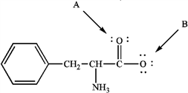phenylalanine

1. Refer to instructions. Assign any formal charges to atoms in this representation of phenylalanine.
ANSWER: | 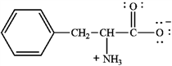
POINTS: | 1

2. Refer to instructions. The oxygen atom labeled "A" has ______ bonding electron pairs.
ANSWER: | two
POINTS: | 1

3. Refer to instructions. The oxygen atom labeled "B" has _____ nonbonding electrons.
ANSWER: | six
POINTS: | 1

Instructions: Use the convention δ−/δ+ and the crossed arrow () to show the direction of the expected polarity of the indicated bonds in the following compound(s).

4. Refer to instructions. The C−F bond in fluorobenzene,
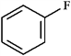
ANSWER: | 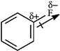
POINTS: | 1

5. Refer to instructions. A C−O bond in tetrahydrofuran,
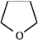
ANSWER: | 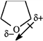
POINTS: | 1

6. The following shows an intermediate used in a Grignard synthesis. Which atom will inductively donate electrons in this species?
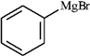
 | a. | C
 | b. | Br
 | c. | Mg
 | d. | H
 | e. | both b and c

ANSWER: | c
POINTS: | 1

7. Consider the structure of acetic acid shown below.
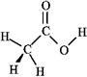
In the electrostatic potential map of acetic acid, in which of the following bonds would the terminal atom appear as the deepest shade of red?
 | a. | C=O
 | b. | C−H
 | c. | C−C
 | d. | O−H

ANSWER: | a
POINTS: | 1

8. Which of the following molecules would exhibit the largest dipole moment?
 | a. | CH₃CH₃
 | b. | CH₃CH₂F
 | c. | CH₃CH₂Cl
 | d. | CH₃CH₂Br

ANSWER: | b
POINTS: | 1

9. Among the following compounds which can function only as a Brønsted-Lowry base?
A | 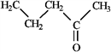
B | 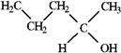
C | 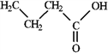
D | 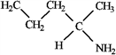

 | a. | A
 | b. | B
 | c. | C
 | d. | D

ANSWER: | d
POINTS: | 1

10. What is the formal charge on the nitrogen atom indicated with the arrow in the following compound?
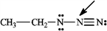
 | a. | 0
 | b. | −1
 | c. | +1
 | d. | −2
 | e. | +2

ANSWER: | c
POINTS: | 1

Instructions: Label the acid and base in each reaction below.

11. Label:
ANSWER: | 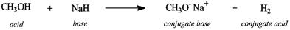
POINTS: | 1

Instructions: Refer to the following equation to answer the question(s) below.
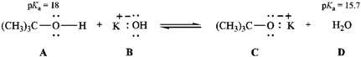

12. Refer to instructions. The strongest Brønsted-Lowry acid in the equation is indicated by letter _____.
ANSWER: | D
POINTS: | 1

13. Refer to instructions. The strongest Brønsted-Lowry base in the equation is indicated by letter _____.
ANSWER: | C
POINTS: | 1

14. Refer to instructions. Will this reaction take place as written in the forward direction? Explain.
ANSWER: | No, the reaction will not take place as written because the strongest acid reacts with the strongest base to give the weakest conjugate acid and the weakest conjugate base. D (pK_{a} = 15.7) is a stronger acid than A (pK_{a} = 18).
POINTS: | 1

15. Circle the Lewis bases in the group of compounds below.
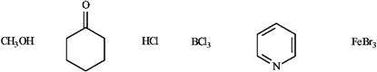
ANSWER: | 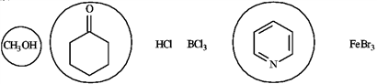
POINTS: | 1

Instructions: Consider the species below to answer the following question.
BF₃ | Fe²⁺ | 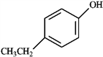 | 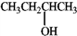

16. Refer to instructions. Which of the following would be common to all?
 | a. | Lewis acids
 | b. | Lewis bases
 | c. | Lewis acids or bases
 | d. | Neither Lewis acids nor bases

ANSWER: | a
POINTS: | 1

17. Draw two resonance structures for the species below.
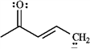
ANSWER: | 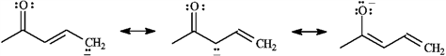
POINTS: | 1

18. Explain why phenol has a lower pK_{a} than ethanol.
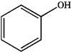
phenol | ethanol

ANSWER: | Phenol is more acidic (has a lower pK_{a}) than ethanol because the phenoxide anion is resonance stabilized by the pi electrons in the ring. Sharing (delocalizing) the negative charge on oxygen with the three ring carbons stabilizes the phenoxide anion relative to undissociated phenol.  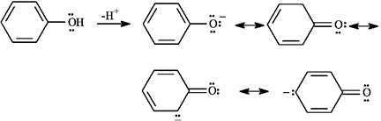  Ethoxide anion has no resonance stabilization. The negative charge is borne fully by oxygen.
POINTS: | 1

Instructions: Consider the reaction below to answer the following question.
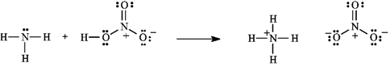

19. Refer to instructions. Using the curved arrow formalism, show the flow of electrons for this reaction.
ANSWER: | 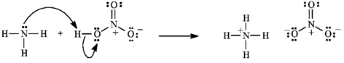
POINTS: | 1

Instructions: Indole is pleasant smelling in highly dilute solutions and has been used in perfumery. Use the structure of indole, below, to answer the following question(s).
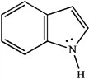

20. Refer to instructions. Indole can function as a Brønsted-Lowry acid in the presence of strong bases. Formulate a reaction, using a generic base (:B−), showing electron flow with arrows, that demonstrates this reactivity of indole.
ANSWER: | 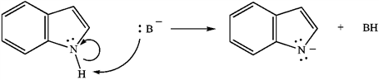
POINTS: | 1

21. Refer to instructions. Indole can function as a Lewis base in the presence of strong acid. Formulate a reaction, using a generic acid (HA), showing electron flow with arrows, that demonstrates this reactivity of indole.
ANSWER: | 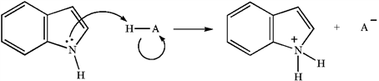
POINTS: | 1

22. The condensed structure for dimethyl ether looks symmetrical. However, dimethyl ether has a dipole moment. Draw a structure that explains this and indicate the expected direction of the molecular dipole moment.
dimethyl ether

ANSWER: | 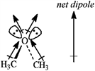
POINTS: | 1

23. Of the bonds found in
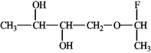
which is the most polar?
 | a. | C−F
 | b. | O−H
 | c. | C−H
 | d. | C−O

ANSWER: | a
POINTS: | 1

24. Which of the following molecules has a dipole moment?
 | a. | 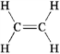
 | b. | 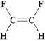
 | c. | 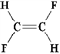
 | d. | 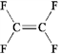

ANSWER: | b
POINTS: | 1

25. Which of the following statements is not true regarding resonance structures?
 | a. | All resonance structures must have the same number of electrons
 | b. | All resonance structures must differ in the hybridization of atoms.
 | c. | All resonance structures must have the same arrangement of atoms
 | d. | All resonance structures must be valid Lewis structures

ANSWER: | b
POINTS: | 1

26. Rank the following in order of decreasing importance as a contributing resonance structure to the molecular structure of acetone, CH₃COCH₃ (more important > less important).
A | 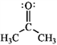
B | 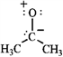
C | 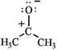

 | a. | A > B > C
 | b. | A > C > B
 | c. | B > A > C
 | d. | C > A > B

ANSWER: | b
POINTS: | 1

27. Draw a Lewis structure for each of the following.
a) | hydroxylammonium ion: ⁺NH₃OH.
b) | azide ion: (N₃−)

ANSWER:
  a) | 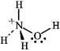
  b)
POINTS: | 1

28. Which is the strongest base (pK_{a} values given for conjugate acid)?
 | a. | NH₃ (pK_{a} = 9.2)
 | b. | CH₃O− (pK_{a} = 16)
 | c. | 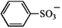 (pK_{a} = −6.5)
 | d. | CH₃CO₂− (pK_{a} = 4.7)
 | e. | H− (pK_{a} = 35)

ANSWER: | e
POINTS: | 1

29. Identify the reactants and product in the reaction below as acids or bases and specify whether they are Lewis and/or Brønsted-Lowry.
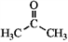 |  | 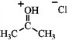

ANSWER:
  base | acid | acid
  (Lewis and Brønsted–Lowry) | (Lewis and Brønsted–Lowry) | (Lewis and Brønsted–Lowry)
POINTS: | 1

30. Draw the conjugate base of each species.
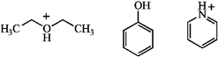
ANSWER: | 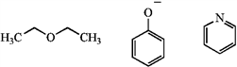
POINTS: | 1

31. Use the curved arrow method to show the electron movement, and label the acid, base, conjugate acid, and conjugate base.
ANSWER: | 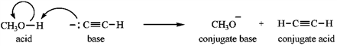
POINTS: | 1

32. Complete this acid-base reaction, and label the acid, base, conjugate base, and conjugate acid.
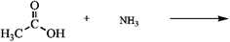
ANSWER: | 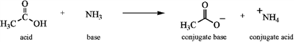
POINTS: | 1

33. In aromatic nitration reactions, nitric acid (HNO₃) is used in conjunction with the stronger acid, sulfuric acid, H₂SO₄, to form an intermediate. Which of the following could be the formula for this intermediate?
 | a. | NO₃−
 | b. | H₃SO₄⁺
 | c. | H₂NO₃⁺
 | d. | HNO₂

ANSWER: | c
POINTS: | 1

34. Draw two resonance forms for the cyclopentadienyl radical.
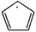
ANSWER: | 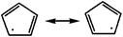
POINTS: | 1

35. The visual pigment in animal cells consists of an isomer of retinal linked to the protein opsin, as shown below. Write an alternative resonance form for this species that shows the positive charge situated on the starred carbon instead of the nitrogen atom and include the curved arrows to show the electron flow.
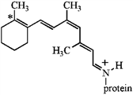
ANSWER: | 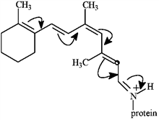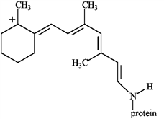
POINTS: | 1

36. Guanidine is a fairly strong amine base that is attached to the amino acid arginine. Draw three resonance forms for the conjugate acid of guanidine.
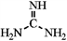
guanidine

ANSWER: | 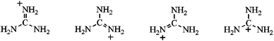
POINTS: | 1

37. Write an equation for the reaction of boron trifluoride, an important reagent in organic chemistry, with trimethylamine. Represent the movement of electrons with a curved arrow, and show the formal charges on the atoms in the product.
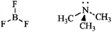
ANSWER: | 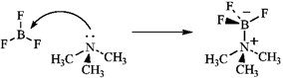
POINTS: | 1

38. Write an equation for the reaction of the alkaloid ephedrine with a proton, showing the structure of its conjugate base.
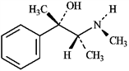
ANSWER: | 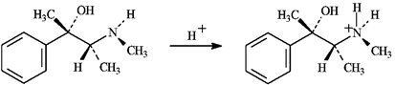
POINTS: | 1

Instructions: Consider the molecules below to answer the following question.
CH₃CH₂NH₂ | CH₃CH₂OH | CH₃CH₂CH₃
1 | 2 | 3

39. Refer to instructions. Which of the following is an accurate description of the noncovalent interactions between like molecules?
 | a. | Only 1 exhibits hydrogen bonding.
 | b. | Only 2 exhibits hydrogen bonding.
 | c. | Only 3 exhibits hydrogen bonding.
 | d. | Only 1 and 2 exhibit hydrogen bonding.
 | e. | All of these exhibit hydrogen bonding.

ANSWER: | d
POINTS: | 1

40. The following is the structure of vitamin C. This compound
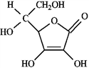
 | a. | is hydrophilic.
 | b. | exhibits dispersion forces.
 | c. | exhibits hydrogen bonding.
 | d. | would be soluble in water.
 | e. | all of these.

ANSWER: | e
POINTS: | 1

41. Which of the following exhibits only dispersion forces?
A | 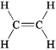
B | 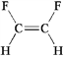
C | 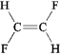
D | 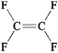

 | a. | only A
 | b. | only B
 | c. | only C
 | d. | only D
 | e. | all except B

ANSWER: | e
POINTS: | 1

