Chapter 2 Supply and Demand
Solutions

2.1 Answer in text.

2.2 The “other things constant” proviso means that we are examining the effect on only one variable (price) on the amount demanded of the good. This is because the amount of a good a person wants to buy depends on things besides price—income, tastes and prices of related goods, for example. If income increases and at the same time the price of the good increased, someone may buy more of the good. This would appear a violation of the law of demand, but actually reflects the greater wealth of the consumer. The proviso allows our analysis to be clearer and more precise.

2.3 No. The concept of equilibrium is useful because it shows us that the direction of the market and economy is changing, even if it never arrives at the equilibrium. The concept of equilibrium is needed to generate order in the analysis.

2.4 No. The supply curve could have shifted, or both could have shifted. We do know that tennis rackets are relatively scarcer than before, but this could be due to either an increase in demand or a decrease in supply.

2.5 Answer in text.

2.6 A shortage (or an excess demand) exists when the quantity demanded exceeds the quantity supplied at the current price. In unregulated competitive markets, we would expect shortages to be a temporary phenomenon. The shortage would disappear once economic agents have had time to adjust to the new situation. Noneconomists often use the term differently. They may refer to a shortage as a situation when price is higher than they like, so that some people cannot buy as much of the good as they would if the price were lower.

2.7 This statement is false. There is confusion of changes in demand (or supply) and changes in quantity demanded (or supplied). A decrease in supply will cause price to increase and cause a reduction in quantity demanded. But, this would be the end of the story. The higher price does not cause the demand curve to shift, so no further changes would take place.

2.8 Answer in text.

2.9 a. Arc-price elasticity of demand = |(6/65)/(–1/108.5)| = 1
Income-price elasticity of demand = (5/67.5)/(100/2050) = 1.51
Cross-price elasticity of demand = (8/66)/(1/110.5) = 13.3

b. They are substitutes because the cross-price elasticity of demand is positive.

c. American’s seats are a normal good since the income elasticity is positive.

d. Larger since elasticity of demand increases with time.

e. The demand elasticity for economy seats in general is less since there are fewer substitutes for economy seats in general.

2.10 Answer in text.

2.11 The cross-price elasticity of demand for study guides with respect to movie passes is zero. Since the price elasticity of demand for movies is unity and the student spends all her money on either movie passes or study guides, then the student will not change her consumption of study guides when the price of movie passes changes.

2.12 a. The figure below shows the demand and supply curves for corn. The original equilibrium is E, with Q* units of corn produced and sold at a price of $5. The purchasing of corn by the government at $10 causes quantity demanded by private consumers to fall to Q1. Private consumers pay $10Q1, which is the area ABQ1O while the government pays BCQ*Q1. If the price-elasticity of demand for corn is 0.5, then a 100 percent increase in price leads to a 50 percent reduction in quantity demanded by private consumers. Hence, Q1 = .5Q*. The amounts spent by private consumers and the government are the same.

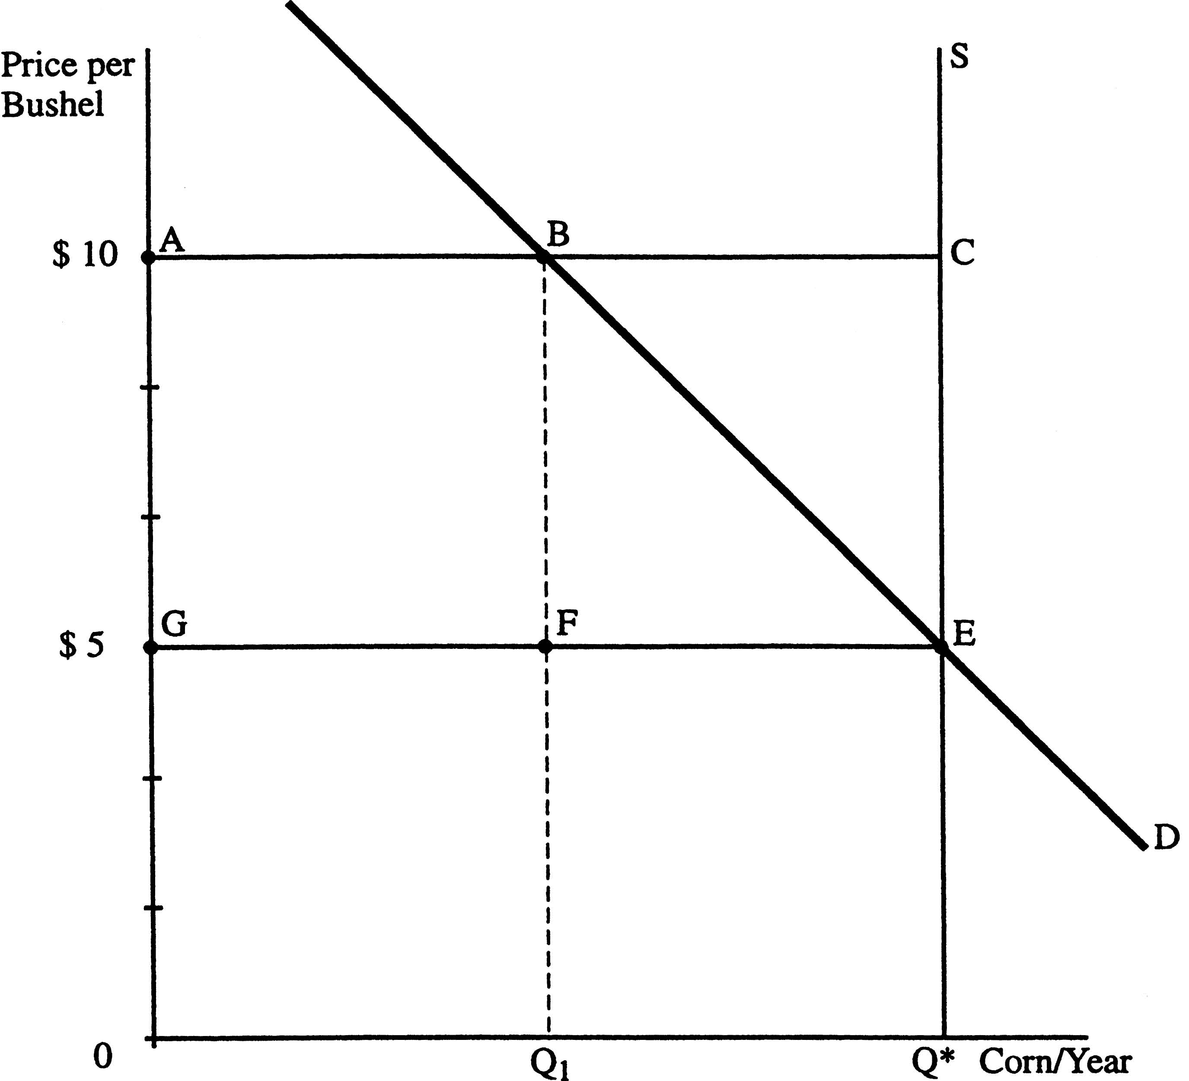
b. Because the supply curve is vertical, the $5 per bushel subsidy has no effect on consumers. They still purchase Q* units and pay $5 per bushel. The government also pays $5 per bushel, so farmers are getting $10 per bushel. Consumers pay GEQ*O and the government pays ACEG. With an elasticity of demand of 0.5, therefore, the cost to the government is the same under the two programs.

2.13 The income elasticity of demand is unity (+1). For a given price, a ten percent change in income will lead to a ten percent change in consumption of movies. The price elasticity of demand is also unity (-1). Holding income constant, the total expenditure on good X is the same regardless of price, so demand is unitary elastic.

2.14 Answer in text.

2.15 Elasticity of demand = (Percentage change in quantity demanded)/(percentage change in price). This can be rearranged to:
Percentage change in price = (Percentage change in quantity demanded)/(Elasticity of demand) = –0.1/-0.4 = .25. Therefore, the price increased by fifty cents. Total spending on gasoline will increase since demand is inelastic and price increased. Total expenditure rises from $2Q to $2(1.25)(.9Q) or from $2Q to $2.25Q or by 12.5 percent.
2.16 For a linear demand curve, the elasticity of demand at a point on the demand curve equals (P/Q)x(1/(slope of the demand curve)). Two parallel demand curves will have the same slope, which we will call b. Further, we are examining the two curves at the same price, so the elasticity of demand for the first demand curve is (P/Q)(1/b) and for the second is (P/2Q)(1/b). Clearly, the elasticities are not the same.
The second situation is one in which the quantity demanded for the second demand curve equals 1.5Q where Q is the quantity demanded for the first demand curve. If the slope of the first demand curve is b, then the elasticity of demand for the first demand curve is (P/Q)(1/b). The elasticity of demand for the second demand curve is (P/1.5Q)(1/(2/3)b) = (P/Q)(1/b). The elasticities are the same.
2.17 Need to draw a graph that would show a perfectly inelastic supply at some amount Q*, a relatively inelastic demand that intersects the supply at a price of $5.7 million and a price ceiling (Pc) set at a price of zero.

2.18 The demand curve should be drawn as perfectly price inelastic. The implied price elasticity of demand equals zero.

2.19 The cross price elasticity would indicate the extent to which systems such as Linux served as substitutes for Microsoft's own operating system and thus would suggest the extent to which Microsoft had monopoly power in the operating system market.

2.20 If basic tier demand elasticity equals unity, profit will increase with an increase in the basic tier rate. This is because total revenue will remain unchanged (demand elasticity equals unity) while total cost will decrease (less output at a higher rate). If demand elasticity exceeds unity, profit could either increase, decrease, or remain unchanged if the basic tier rate is increased. This is because total revenue will decrease (due to demand being elastic) as will total cost (less output at a higher rate). What happens to profit will depend on the magnitude of the decrease in total revenue relative to the magnitude of the decrease in total cost.

2.21 With a government-set price ceiling of basically zero (apart from some typically minor hookup charge) for Internet usage, the supply-demand framework developed in this chapter predicts the outcome: a shortage of Internet capacity and delays confronting those who wish to use it.

2.22 Your price elasticity will be lower the less time you leave to shop for a present. This is because less time leaves you with a diminished opportunity to scour for substitute gifts.

2.23 Because the authorities are unwilling to rely on prices to allocate take-off and landing slots, they have effectively set a price ceiling at $0. The supply of take-off and landing slots is fixed between 3 p.m. and 8 p.m. (using the supply and demand framework, the supply curve in this example is vertical). After removing the regulated limit, in early 2007, the quantity demanded exceeded the quantity supplied of slots by 30-percent. Those that were willing to wait the longest were allocated the scarce take-off and landing slots. Passengers are worse off under this system.

2.24 The 2007 law should not be reinstated. If a consumer purchases a ticket for $10,000, then they must have valued a seat near the stage at a U2 concert at $10,000 or higher. The exchange likely benefits both the buyer and the seller. Beneficial trades should not be banned.

