CHAPTER 1: Discussion Questions and Problems

1. Differentiate the following terms/concepts:

- Prospect and probability distribution

A prospect is a lottery or series of wealth outcomes, each of which is associated with a probability, whereas a probability distribution defines the likelihood of possible outcomes.

- Risk and uncertainty

Risk is measurable using probability, but uncertainty is not. Uncertainty is when probabilities can’t be assigned or the possible outcomes are unclear.

- Utility function and expected utility

A utility function, denoted as u(), assigns numbers to possible outcomes so that preferred choices receive higher numbers. Utility can be thought of as the satisfaction received from a particular outcome.

- Risk aversion, risk seeking, and risk neutrality

Risk aversion describes someone who prefers the expected value of a lottery to the lottery itself. Risk seeking describes someone who prefers a lottery to the expected value of a lottery. And risk neutrality describes someone whose utility of the expected value of a lottery is equal to the expected utility of the lottery.

2. When eating out, Rory prefers spaghetti over a hamburger. Last night she had a choice of spaghetti and macaroni and cheese and decided on the spaghetti again. The night before, Rory had a choice between spaghetti, pizza, and a hamburger and this time she had pizza. Then, today she chose macaroni and cheese over a hamburger. Does her selection today indicate that Rory’s choices are consistent with economic rationality? Why or why not?

Rory’s preferences are consistent with rationality. They are complete and transitive. We see that her preference ordering is:

Pizza spaghetti macaroni and cheese hamburger

3. Consider a person with the following utility function over wealth: u(w) = e^{w}, where e is the exponential function (approximately equal to 2.7183) and w = wealth in hundreds of thousands of dollars. Suppose that this person has a 40% chance of wealth of $50,000 and a 60% chance of wealth of $1,000,000 as summarized by P(0.40, $50,000, $1,000,000).

a. What is the expected value of wealth?

E(w) = .4 * .5 + .6 * 10 = 6.2

U(P) = .4e^{0.50} + .6e¹⁰ = 13,216.54

b. Construct a graph of this utility function.

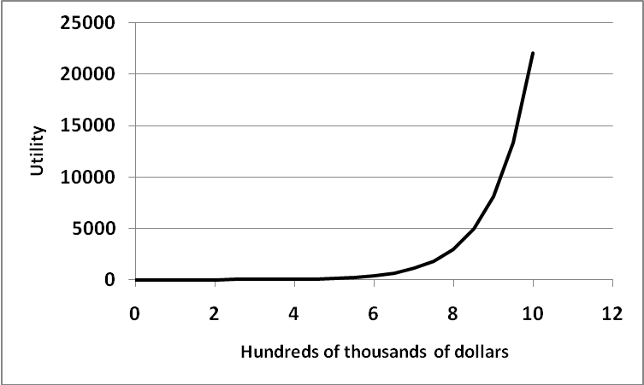
The function is convex.

c. Is this person risk averse, risk neutral, or a risk seeker?

Risk seeker because graph is convex.

d. What is this person’s certainty equivalent for the prospect?

e^{w} = 13,216.54 gives w = 9.4892244 or $948,922.44

4. An individual has the following utility function: u(w) = w^{.5} where w = wealth.

a. Using expected utility, order the following prospects in terms of preference, from the most to the least preferred:

P1(.8, 1,000, 600)
P2(.7, 1,200, 600)
P3(.5, 2,000, 300)

Ranking: P2, P3, P1 with expected utilities 31.5972, 31.0209, and 30.1972 for prospects 2, 3, and 1, respectively

b. What is the certainty equivalent for prospect P2?

998.3830

c. Without doing any calculations, would the certainty equivalent for prospect P1 be larger or smaller? Why?

The certainty equivalent for P1 would be smaller because P2 is ranked higher than P1.

5. Consider two prospects:

Problem 1: Choose between
Prospect A: $2,500 with probability .33,
$2,400 with probability .66,
Zero with probability .01.
And Prospect B: $2,400 with certainty.

Problem 2: Choose between
Prospect C: $2,500 with probability .33,
Zero with probability .67.
And Prospect D: $2,400 with probability .34,
Zero with probability .66.

It has been shown by Daniel Kahneman and Amos Tversky (1979, “Prospect theory: An analysis of decision under risk,” Econometrica 47(2), 263-291) that more people choose B when presented with problem 1 and when presented with problem 2, most people choose C. These choices violate expected utility theory. Why?

This is an example of the Allais paradox. The first choice suggests that
u(2,400) > .33u(2,500) + .66u(2,400) or .34u(2,400) > .33 u(2,500)
while the second choice suggests just the opposite inequality.

